**Estimating reliable origin-destination flow demand for a subarea**

Development Goal:

(1) A learning-document using Excel spreadsheet and NEXTA

(2) A TRB journal paper.

<http://www.trb.org/committeeandpanels/onlinedirectory.aspx#DetailsType=Committee&ID=1004>

Each team member contribute at least 3 pages of write-up (in this online document) and a short presentation to be delivered in the class

Importance:

A subarea analysis capability is needed in conjunction with static and dynamic network analysis models to allow consideration and rapid evaluation of a large number of scenarios and support transportation network planning and operations decisions for situations that may not require analysis on a complete network representation.

Subarea analysis is an essential capability for integrating operational planning tools into regional planning applications for several reasons. First, analyses of operational decisions and Intelligent Transportation System (ITS) deployment alternatives generally require a high level of detail in only a portion of the regional or metropolitan area network rather than in the entire network. In many cases, greater level of detail in network and operational representation is necessary only for directly affected areas, not for outer reaches of the network. In other cases, large-scale regional networks entail minimal secondary and tertiary impacts outside a given subarea due to weak structural interactions, in which case a subarea analysis would be satisfactory. The computational advantages of using a subarea network instead of a large regional network are evident for cases where consideration and rapid evaluation of large number of policy scenarios are needed.

Given data:

(1) West Jordan Network: NEXTA internal Internal_release\sample_data_sets\Salt_Lake_City_West_Jordan

(2) AADT counts (Google Earth Link): <http://www.udot.utah.gov/main/f?p=100:pg::::1:T,V:2256>

Anusha, please work with the other students to check or reinput the AADT counts in the West Jordan network.

(3) Traffic turning movement counts: provided by Jeff Taylor

References related to particular software packages

Sub-Area Analysis Using TransCAD

<http://transportation.ky.gov/Planning/Documents/Sub-AreaAnalysisUsingTransCAD.pdf>

Trip generation using Cube

<http://www.fsutmsonline.net/images/uploads/mtf-files/Ken_Kaltenbach_TripGeneration.pdf>

Keyword: Stand-Alone subarea

Consider the Available Data

¾ GIS data for roadways and required attributes

¾ Land use data (parcels, imagery, ES202 data, Census, etc.)

¾ Obtain and review the traffic data

**Module 1: Produce base production and attraction table for Internal Trips**

Author: Imanuel Aswandi

Input: demographic and socio economic data, zone-level statistics

Output: zonal productions and attractions, by different trip purposes, for internal zones (that do not carry through traffic)

References:

ITE Trip generation handbook: <http://www.ite.org/emodules/scriptcontent/orders/ProductDetail.cfm?pc=IR-016G>

Census data: American Fact Finder <[http://factfinder2.census.gov/](http://www.google.com/url?q=http%3A%2F%2Ffactfinder2.census.gov%2F&sa=D&sntz=1&usg=AFQjCNFcRmKMGywX45UqX9qLUzobGjUzzg)> and Wasatch Front Regional Council (WFRC)

Trip generation models are divided into two kinds: production trips and attraction trips. Production trips represent with the number home-based trips to and from zones where trip makers reside. Attraction trips represent the number of home-based trips to and from each zone at the non-home end of the trip. In this module, ITE Trip Generation method will be used to estimating the number of production and attraction for internal-internal trips.

Trip Generation manual is a collection of traffic data collected by ITE based on its land use. It is widely used throughout United States even though it relies on voluntary submittal of data from the transportation community.

When estimating the number of production and attraction trips, the analyzed subarea need to be divided into several zones. WFRC has established number of zones for the study area and also in the earlier study, the traffic network of West Jordan has been created in NEXTA, including the zone area. As we are correlating the zone area between NEXTA and WFRC, it would be preferable to adjust the zone area in NEXTA to represents the zone area that has been established by WFRC.

After separating the study area into several zones, do the following steps:

1. Determine the internal-internal zones based on NEXTA traffic network previously created correlated with the number of zoned established by WFRC. The following table shows the number of zones chosen to be internal-internal zones, including its relation with the number of zones from WFRC.

|  |  |  |  |
| --- | --- | --- | --- |
| **NEXTA** | **WFRC** | **NEXTA** | **WFRC** |
| 8 | 1,288 | 29 | 1,358 |
| 12 | 1,324 | 30 | 1,360 |
| 17 | 1,289 | 31 | 1,318 |
| 19 | 1,352 | 32 | 1,285 |
| 20 | 1,357 | 33 | 1,351 |
| 21 | 1,407 | 34 | 1,322 |
| 22 | 1,406 | 35 | 1,290 |
| 23 | 1,361 | 36 | 1,299 |
| 24 | 1,325 | 37 | 1,349 |
| 25 | 1,355 | 38 | 1,398 |
| 26 | 1,323 | 39 | 1,404 |
| 27 | 1,348 | 40 | 1,296 |
| 28 | 1,359 |  |  |

1. Observe the zone to determine which land use is more appropriate to represent the zone to estimate the number of trips according to ITE Trip Generation. For example: shopping center is land use number 820, general office building is land use number 710, and so on.
2. Determine which function in ITE Trip Generation Manual is more appropriate, whether the function of the graph of the average rate of the data according to the land use. For example: land use of shopping center gives two options based on the function of the graph, which is  
   where X = 1000 ft2 gross leasable area  
   or the average rate of 42.94 trips for every 1000 ft2 gross leasable area.
3. Determine which socio economic/demographic data are needed, such as: the area of the zone, the number of population, the number of household, etc. These data can be obtained from WFRC and/or American Fact Finder.
4. Treat the percentage entering and exiting as the number of production and attraction, respectively. For example: 50% entering and 50% exiting.
5. Determine trip reduction based on Trip Generation Handbook. There are technically three trip reduction: Internal Capture Trips, Pass-by Trips, and Transit Reduction Trips.
   1. Determining Internal Capture Trips can be done by executing a survey in the area. However, for this project purposes we are going to assume 15% for this internal trips inside the zone.
   2. Pass-by trips are made by traffic already using the adjacent roadway and enter the site as an intermediate stop on the way from another destination. ITE Trip Generation Handbook has conducted a survey for the pass-by trips and we are adopting this percentage to accommodate these trips in our study area. For example: there are approximately 34% pass-by trips for shopping center that needs to be reduced from the number of trips generated.
   3. Transit Reduction trips needs to be considered since the number of transit going through the study area might decrease the number of trips. However, there are not many transits that go through the study area, thus, transit are assumed not to affect the trip generation in the study area.

The following table summarized the number of production and attraction for internal-internal zones.

|  |  |  |  |  |  |
| --- | --- | --- | --- | --- | --- |
| **Zone No.** | **Total Production** | **Total Attraction** | **Zone No.** | **Total Production** | **Total Attraction** |
| 8 | 1179 | 1179 | 29 | 2880 | 2878 |
| 12 | 2308 | 2308 | 30 | 1992 | 1991 |
| 17 | 9279 | 9277 | 31 | 8768 | 8765 |
| 19 | 6747 | 6746 | 32 | 8700 | 8700 |
| 20 | 2386 | 2383 | 33 | 3617 | 3615 |
| 21 | 9648 | 9647 | 34 | 10663 | 10658 |
| 22 | 1374 | 1374 | 35 | 1644 | 1644 |
| 23 | 5577 | 5576 | 36 | 4711 | 4710 |
| 24 | 3739 | 3739 | 37 | 7978 | 7978 |
| 25 | 4494 | 4493 | 38 | 9020 | 9020 |
| 26 | 2168 | 2166 | 39 | 1657 | 1656 |
| 27 | 3702 | 3700 | 40 | 1392 | 1391 |
| 28 | 5128 | 5126 |  |  |  |
|  |  |  | **Total** | **120,751** | **120,720** |

The detail calculation spreadsheet can be reviewed here.

# **Module 2: External Trip Estimation:** Create OD Demand Matrix through singly constrained trip distribution

Author: Kevin John Croshaw

Reference: chapter 5: NCHRP report 365

Input: AADT counts and other zone-level statistics

Output: Seed OD trip table using gravity model

Step 1: estimate through trip percentage at external stations

Apply equations from the chapter

Step 2: distribute through trips between stations: (you might need to aggregate some boundary zones)

Step 3: Estimate external-internal trip production and attraction

Step 4: distribute internal-external, external-internal trips, as well as internal-to-internal trips (from module 1) using gravity model:

## 2.1 Introduction

In order to create the OD Demand Matrix for the West Jordan Network, the OD Demand for the external and internal zones must be calculated. In order to do this, this complex network needs to be separated. After this separation, different modeling techniques can be used in order to calculate the OD demand Matrix.

### Separation of Zones

Since there are numerous exterior zones on the network, 6 major exterior zones will be used with the rest being considered as minor exterior zones. Figure 1 shows how the OD Demand Matrix will be separated by station type. 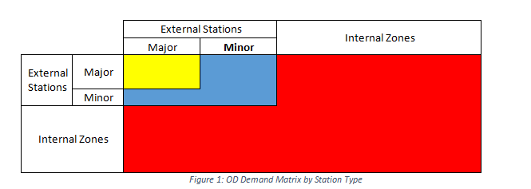

### Methods to Distribute Traffic

Distribution of the traffic will be completed using the different methods listed below:

1. Major External to Major External: NCHRP formal relying on ADT
2. Minor External to Minor External: NCHRP formal relying on ADT
3. Major External to Internal: Gravity Model using estimated accessibility

Calculation for each of these matrices are shown in the following sections. The values will then be combined into the OD Matrix shown in Figure 1.

## 2.2 Major External to Major External OD Matrix

The total productions from each major external station will be distributed to each major external station using the NCHRP Report 365: Travel Estimation Techniques for Urban Planning. This is a calibrated regression model used to calculate major external to major external traffic distribution. The following six stations will be considered as major external stations:

1. Redwood Road South
2. Redwood Road North
3. 9000 South East
4. 9000 South West
5. 10400 South East
6. 10400 South West

The variables needed to compute this OD matrix are the Average Daily Traffic (ADT) and population data. The following shows how these values are found and calculated for each external major station.

### Average Daily Traffic Data

Using the Annual Average Daily Traffic (AADT) data from the Utah Department of Transportation (UDOT), the 2011 data for each major external station are shown in Table 1.

*Table 1: 2011 AADT Data*

|  |  |
| --- | --- |
|  | AADT (veh/day) |
|  |  |
| Redwood (South) | 16100 |
| Redwood (North) | 34970 |
| 90000 S (East) | 37125 |
| 90000 S (West) | 37990 |
| 10400 S (East) | 41355 |
| 10400 S (West) | 13415 |

Each major external station will be split into two categories, through trips and External to Internal trips. The through trip data will be used to calculate the Major External to Major External OD Matrix. The External to Internal data will be used later.

### Population Data

#### *Household Size*

Census data is needed in order to find the approximate population for the area. According to the 2010 census shown in Figure 2, the average household size is 3.21 people and 2.62 people for owners and renters respectively. It also shows that 70.4% and 29.6% of the people in Utah are owners and renters respectively. With this information, an approximation can be made of household size using a weighted average shown in the equation below. This average will be assumed the same in the West Jordan Network area. The calculation shows the average household size in Utah, and the area of interest is 3.09 people.

HHsize=Owner*70.4%+Renter*29.6%100%=3.09 people

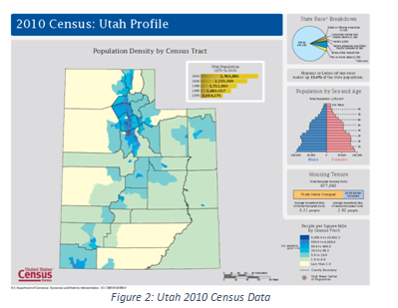

### Number of Households

Google Earth is used to approximate the total number of households. Small sections of the area were selected to count households. An example is shown in Figure 3.

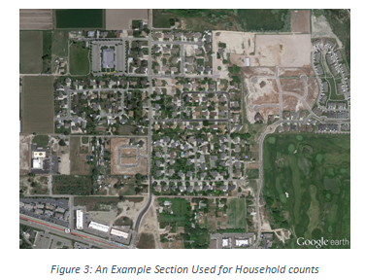



The area can be measured using the Google Earth area tool. This is done at least three times to ensure accuracy. The number of households per square mile is found to be 834 using the equation below.



Using the total area of the West Jordan Network of 6.955mi2, the approximate number of households in the West Jordan Network is 5796. This value is multiplied by the approximate number of persons per household, 3.09, which gives an approximate population of the West Jordan Network of 17,910. This calculation is shown below.



### Traffic Distribution

Using the gathered data, the percentage of the AADT that makes a through trip can be calculated using the following equation found in NCHRP Report 365.

 Where:

*Yi* = Percentage of the ADT at external station i, that are through trips

*I* = Interstate (0 or 1)

*PA* = Principal Arterial (0 or 1)

*MA* = Minor Arterial (0 or 1)

*ADTi* = Average Daily Traffic at External Station i

*PTKSi* = Percentage of trucks excluding vans and pickups at external station i

*PPSi* = Percentage of vans and pickups at external stations i

*POP* = Population inside the cordon area

Compared to the gravity model, this model does not consider the distance between zones as friction factors.

When collecting the data, the values of PTKS and PPS were estimated using the percent trucks data given from UDOT. For this area, all external zones are located on a principle arterial. The percentage of the ADT, and total vehicles at each external station that are through trips are shown in Table 2.

*Table 2: Total through Trips and Internal to External, External to Internal Trips*

|  |  |  |  |  |  |
| --- | --- | --- | --- | --- | --- |
|  | Population | AADT (veh/day) | External-External Yi (%) | Through Trips (Yi*AADT) | External to Internal [(100-Yi)*AADT] |
|  |  |  |  |  |  |
| Redwood (South) | 17910 | 16100 | 41.38 | 6661.55 | 9438.45 |
| Redwood (North) | 17910 | 34970 | 38.47 | 13453.12 | 21516.88 |
| 90000 S (East) | 17910 | 37125 | 41.68 | 15473.35 | 21651.65 |
| 90000 S (West) | 17910 | 37990 | 41.78 | 15873.31 | 22116.69 |
| 10400 S (East) | 17910 | 41355 | 43.78 | 18103.84 | 23251.16 |
| 10400 S (West) | 17910 | 13415 | 36.36 | 4878.21 | 8536.79 |

Using the through trip data, the total through trips for each major external station can be distributed to the other major external station using the following equation for principal arterials.

Where:

*Yij* = Percentage distribution of through-trip ends from origin station i to destination station j

*PTTDESj* = Percentage through-trip ends at destination station j

*RTECONij* = Route continuity between stations i and j: 1 = Yes, 0 = No

*ADTi* = Average Daily Traffic at External Station j

The percentage through-trip ends at destination j could not be found with the given UDOT data. Therefore, this percentage will be evenly distributed throughout each external station. Route continuity for this example is when the origin and destination occur on the same roadway. Using the given data, the percentage and vehicle distribution from origin to each destination were calculated as shown in Table 3.

*Table 3: Total trips from origin to each major external station*

|  |  |  |  |  |  |  |  |
| --- | --- | --- | --- | --- | --- | --- | --- |
| Origin | Destination | PTTDES | RTECON | AADT/ AADTtot | % Destination | % Normalized | Total Trips |
|  |  |  |  |  |  |  |  |
| Redwood (South) | Redwood (North) | 20 | 1 | 0.1933 | 37.10 | 44.04 | 2933.46 |
|  | 9000 S (East) | 20 | 0 | 0.2052 | 12.96 | 15.38 | 1024.79 |
|  | 9000 S (West) | 20 | 0 | 0.2099 | 13.18 | 15.64 | 1042.04 |
|  | 10400 S (East) | 20 | 0 | 0.2285 | 14.03 | 16.65 | 1109.12 |
|  | 10400 S (West) | 20 | 0 | 0.0741 | 6.98 | 8.29 | 552.11 |

This was done for each external station. Now that all trips have been distributed to each major external station, the final OD Demand matrix can be created for the major exterior to major exterior section as shown in Table 4.

*Table 4: Major External to Major External Station OD Demand Matrix*

|  |  |  |  |  |  |  |  |
| --- | --- | --- | --- | --- | --- | --- | --- |
| Origin | Destination | Total |  |  |  |  |  |
|  | Redwood (South) | Redwood (North) | 9000 S (East) | 9000 S (West) | 10400 S (East) | 10400 S (West) |  |
| Redwood (South) | 0.00 | 2933.46 | 1024.80 | 1042.04 | 1109.13 | 552.12 | 6661.55 |
| Redwood (North) | 5473.56 | 0.00 | 2193.47 | 2230.38 | 2373.97 | 1181.75 | 13453.12 |
| 9000 S (East) | 1501.25 | 2433.73 | 0.00 | 7420.56 | 2749.25 | 1368.56 | 15473.35 |
| 9000 S (West) | 1544.32 | 2503.55 | 7589.48 | 0.00 | 2828.13 | 1407.83 | 15873.31 |
| 10400 S (East) | 1780.51 | 2886.46 | 3012.76 | 3063.46 | 0.00 | 7360.65 | 18103.84 |
| 10400 S (West) | 439.98 | 713.26 | 744.47 | 757.00 | 2223.50 | 0.00 | 4878.21 |
| Total | 10739.61 | 11470.46 | 14564.98 | 14513.44 | 11283.98 | 11870.91 | 74443.38 |
|  |  |  |  |  |  |  |  |

## 2.3 Minor Exterior to Minor Exterior OD Matrix

The total productions from each minor external station will be distributed to each minor external station using the NCHRP Report 365: Travel Estimation Techniques for Urban Planning. This is a calibrated regression model used to calculate major external to major external traffic distribution. The following ten stations will be considered as major external stations:

1. 7000 South (East)
2. 7000 South (West)
3. 7800 South (East)
4. 7800 South (West)
5. 9800 South (East)
6. 9800 South (West)
7. 700 West (North)
8. Center Street (North)
9. 1300 West (North)
10. 1300 West (South)

The variables needed to compute this OD matrix are the Average Daily Traffic (ADT) and population data. The following shows how these values are found and calculated for each external minor station. The population data is continuous throughout the area and is shown earlier in the document.

### Average Daily Traffic Data

Using the Annual Average Daily Traffic (AADT) data from the Utah Department of Transportation (UDOT), the 2011 data for each major external station are shown in Table 5.

*Table 5: 2011 AADT Data*

|  |  |
| --- | --- |
|  | AADT (veh/day) |
|  |  |
| 7000 S (East) | 35830 |
| 7000 S (West) | 28910 |
| 7800 S (East) | 17880 |
| 7800 S (West) | 23160 |
| 9800 S (East) | 1885 |
| 9800 S (West) | 1885 |
| 700 W (North) | 12060 |
| Center St. (North) | 4000 |
| 1300 W (North) | 8360 |
| 1300 W (South) | 14675 |

Each minor external station will be split into two categories, through trips and External to Internal trips. The through trip data will be used to calculate the Minor External to Minor External OD Matrix. The External to Internal data will be used later.

### Traffic Distribution

Using the gathered data, the percentage of the AADT that makes a through trip can be calculated using the following equation found in NCHRP Report 365.

Where:

*Yi* = Percentage of the ADT at external station i, that are through trips

*I* = Interstate (0 or 1)

*PA* = Principal Arterial (0 or 1)

*MA* = Minor Arterial (0 or 1)

*ADTi* = Average Daily Traffic at External Station i

*PTKSi* = Percentage of trucks excluding vans and pickups at external station i

*PPSi* = Percentage of vans and pickups at external stations i

*POP* = Population inside the cordon area

Compared to the gravity model, this model does not consider the distance between zones as friction factors.

When collecting the data, the values of PTKS and PPS were estimated using the percent trucks data given from UDOT. For this area, all external zones are located on a principle arterial. The percentage of the ADT, and total vehicles at each external station that are through trips are shown in Table 6.

*Table 6: Total through Trips and Internal to External, External to Internal Trips*

|  |  |  |  |  |  |
| --- | --- | --- | --- | --- | --- |
|  | Population | AADT (veh/day) | External-External Yi (%) | Through Trips (Yi*AADT) | External to Internal [(100-Yi)*AADT] |
|  |  |  |  |  |  |
| 7000 S (East) | 17910 | 35830 | 46.21 | 16558.35 | 19271.65 |
| 7000 S (West) | 17910 | 28910 | 45.38 | 13120.30 | 15789.70 |
| 7800 S (East) | 17910 | 17880 | 28.03 | 5011.70 | 12868.30 |
| 7800 S (West) | 17910 | 23160 | 28.66 | 6638.41 | 16521.59 |
| 9800 S (East) | 17910 | 1885 | 26.11 | 492.18 | 1392.82 |
| 9800 S (West) | 17910 | 1885 | 26.11 | 492.18 | 1392.82 |
| 700 W (North) | 17910 | 12060 | 27.70 | 3340.77 | 8719.23 |
| Center St. (North) | 17910 | 4000 | 26.73 | 1069.36 | 2930.64 |
| 1300 W (North) | 17910 | 8360 | 24.01 | 2007.01 | 6352.99 |
| 1300 W (South) | 17910 | 14675 | 24.77 | 3634.27 | 11040.73 |

Using the through trip data, the total through trips for each major external station can be distributed to the other major external station using the following equation for principal arterials and minor arterials respectivley.

Where:

*Yij* = Percentage distribution of through-trip ends from origin station i to destination station j

*PTTDESj* = Percentage through-trip ends at destination station j

*RTECONij* = Route continuity between stations i and j: 1 = Yes, 0 = No

*ADTi* = Average Daily Traffic at External Station j

For this exercise, only 7000 S is a major arterial. The rest will be considered as a minor arterial. The percentage through-trip ends at destination j could not be found with the given UDOT data. Therefore, this percentage will be evenly distributed throughout each external station. Route continuity for this example is when the origin and destination occur on the same roadway. Using the given data, the percentage and vehicle distribution from origin to each destination were calculated as shown in Table 7 for major arterials and Table 8 for minor arterials.

*Table 7: Total trips from origin to each major external station*

|  |  |  |  |  |  |  |  |
| --- | --- | --- | --- | --- | --- | --- | --- |
| Origin | Destination | PTTDES | RTECON | AADT/ AADTtot | % Destination | % Normalized | Total Trips |
|  |  |  |  |  |  |  |  |
| 7000 S (East) | 7000 S (West) | 12.50 | 1 | 0.1945 | 33.03 | 65.14 | 10786.73 |
|  | 7800 S (East) | 12.50 | 0 | 0.1203 | 4.96 | 9.79 | 1620.73 |
|  | 7800 S (West) | 12.50 | 0 | 0.1558 | 6.58 | 12.98 | 2149.97 |
|  | 9800 S (East) | 12.50 | 0 | 0.0127 | 0.05 | 0.11 | 17.48 |
|  | 9800 S (West) | 12.50 | 0 | 0.0127 | 0.05 | 0.11 | 17.48 |
|  | 700 W (North) | 6.25 | 0 | 0.0811 | 0.00 | 0.00 | 0.00 |
|  | Center St. (North) | 6.25 | 0 | 0.0269 | 0.00 | 0.00 | 0.00 |
|  | 1300 W (North) | 12.50 | 0 | 0.0562 | 2.04 | 4.03 | 666.50 |
|  | 1300 W (South) | 12.50 | 0 | 0.0987 | 3.98 | 7.85 | 1299.48 |

*Table 8: Total trips from origin to each minor external station*

|  |  |  |  |  |  |  |
| --- | --- | --- | --- | --- | --- | --- |
| Origin | Destination | RTECON | AADT/ AADTtot | % Destination | Normalized % | Total Trips |
|  |  |  |  |  |  |  |
| 7800 S (East) | 7000 S (East) | 0 | 0.2410 | 20.26 | 20.31 | 1018.10 |
|  | 7000 S (West) | 0 | 0.1945 | 16.23 | 16.27 | 815.36 |
|  | 7800 S (West) | 1 | 0.1558 | 43.28 | 43.38 | 2174.26 |
|  | 9800 S (East) | 0 | 0.0127 | 0.47 | 0.47 | 23.57 |
|  | 9800 S (West) | 0 | 0.0127 | 0.47 | 0.47 | 23.57 |
|  | 700 W (North) | 0 | 0.0127 | 0.47 | 0.47 | 23.57 |
|  | Center St. (North) | 0 | 0.0811 | 6.40 | 6.42 | 321.68 |
|  | 1300 W (North) | 0 | 0.0562 | 4.25 | 4.26 | 213.28 |
|  | 1300 W (South) | 0 | 0.0987 | 7.93 | 7.95 | 398.30 |

This was done for each external station. Now that all trips have been distributed to each major external station, the final OD Demand matrix can be created for the major exterior to major exterior section as shown in Table 9.

*Table 9: Minor External to Minor External Station OD Demand Matrix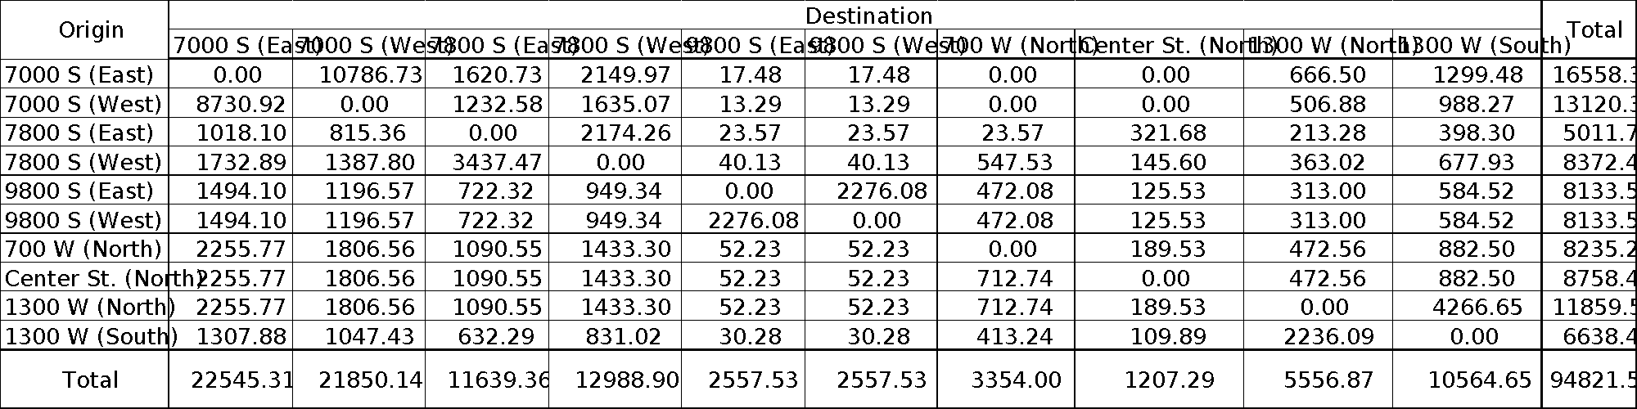*

## Gravity Model

The total productions and attractions from each internal station will be used along with all the External to Internal productions and attractions from the major and minor exterior zones. All of the productions and attractions form each zone in the data set were used along with travel times between zones to find the OD Matrix.

The friction factors for each trip purpose need to be calculated. It will be assumed that the distribution between the Home Base Work (HBW), Home Based Other (HBO) and Non Home Based (NHB) will be even. In order to calculate the friction factors, the following equation will be used.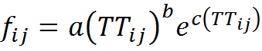

Where:

*fij* = friction factor from origin station i to destination station j

*a, b, and c* = coefficients

*TTij* = Travel Time from zone i to zone j

The coefficients used in the formula are given in table

*Table 10: Coefficients to calculate the friction factor*

|  |  |  |  |
| --- | --- | --- | --- |
| Trip Purpose | a | b | c |
| HBW | **28507** | **-0.02** | **-0.123** |
| HBO | **139173** | **-1.285** | **-0.094** |
| NHB | **219113** | **-1.332** | **-0.1** |

Using the friction factors, the total trips from origin to destination can be calculated using the following formula. 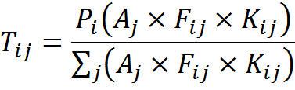

Where:

*Tij* = Total trips from origin station i to destination station j

*Aj* = Attractiveness of destination zone j (The balanced attraction)

*Fij* = Friction Factor from origin station i to destination station j

*Aj* = Productions from origin zone i

This function is solved in Excel using lookup tables. The function allows excel to look at the balanced attraction depending on the destination zone. This value is then multiplied by the friction factor calculated earlier. Another lookup table is used to find the production finding the value of the production at the origin station.

This calculation produces the total trips by trip purpose for each zone. The sum of these values gives the total trips per day for origin zone i to destination zone j. These values can be put in matrix form using the given excel values shown in Table 12

This is not the final OD matrix. This matrix has distributed the productions and attractions for all internal zones along with the productions and attractions generated for the external to internal trips for both the major and minor external stations. In order to produce the final matrix, the major and minor external to external station matrices must be added.

## Final OD Matrix

In order to complete the OD matrix, all matrices produced can be added together. The completed OD matrix using the gravity model does not include the through trips generated for the external to external station OD matrices. This matrix is shown on Table 13.

It is important to check the values to assure that all the AADT values are accounted for. For this example, the Major External to Major External Stations will be examined. In Table 11, the given AADT Values are given along with the total production values given in the final OD Matrix

*Table 11: AADT Values for the Major External Stations*

|  |  |  |  |
| --- | --- | --- | --- |
|  | AADT (veh/day) | Total Productions (veh/day) | Total Attractions (veh/day) |
| Redwood (South) | 16100 | 16006 | 18489 |
| Redwood (North) | 34970 | 34755 | 34346 |
| 90000 S (East) | 37125 | 37495 | 31517 |
| 90000 S (West) | 37990 | 37770 | 38274 |
| 10400 S (East) | 41355 | 41125 | 30252 |
| 10400 S (West) | 13415 | 13332 | 20228 |

The value of the total productions and attractions are close to the original AADT values given. The reason these values are different is because the gravity model distributed vehicles from major external to major external and from minor external to minor external stations. This was already completed using the method explained in the NCHRP Report 365. Vehicles were double counted. This matrix can be further manipulated to get more exact values. This will not be done in this section of the document. Since most of the values are close, we can conclude that this matrix represents the demand for the West Jordan Network.

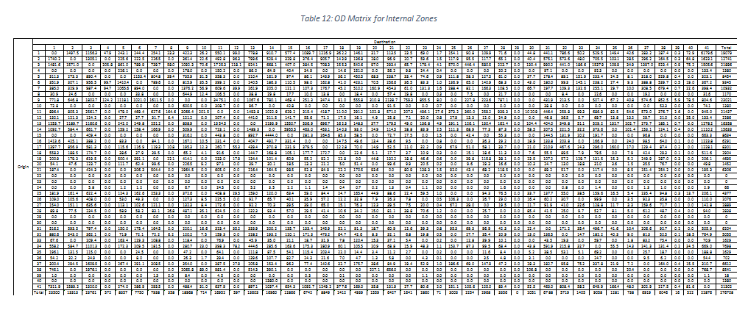

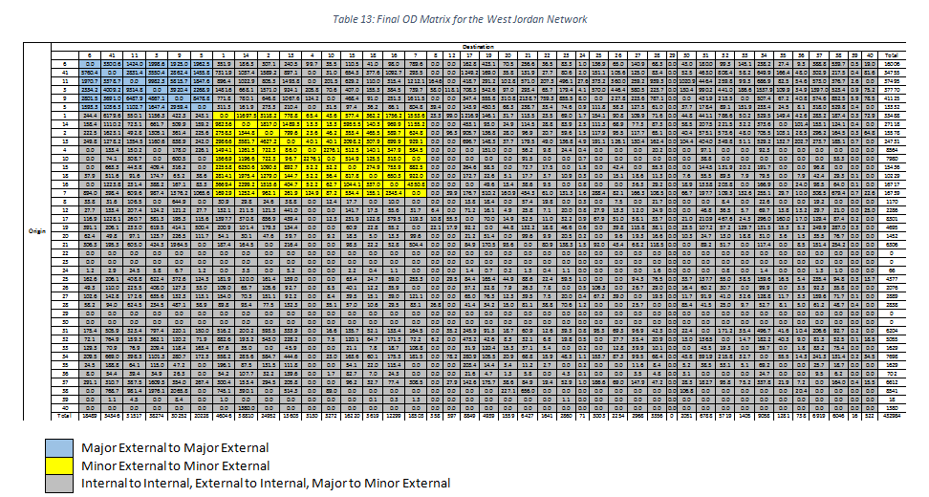

**Module 3: Trip Distribution Using a Doubly Constrained Model**

Author: Amanda Jean Harris

**[Excel Spreadsheet](https://docs.google.com/file/d/0B7B_ItZxmow6VURBTjBVS1FKUlU/edit?usp=sharing)**

**3.1 Model**

Problem Statement: Develop a doubly-constrained optimization model to determine the trip production and attraction for all the zones in the study area.

Notation: The following notation is used throughout this module:

= trips

= Trips produced at zone *i*

= Trips attracted to zone *j*

= Estimated Trips established by the doubly-constrained model for either zones *i* or *j*

= Target Trips based on historical data and models for either zones *i* or *j*

= sum for all zones *i* or *j*

= calibration factor for production

= calibration factor for attraction

= Origin, *i*

= Destination, *j*

= positive or negative error in trip estimation for zones *i* or *j*

= potential deviation for zones *i* or *j*

Input:Trip Production and Attraction for each zone, AADT rate, and travel time between zones.

Output: Updated Trip Table, doubly-constrained for production and attraction

*Step 1: Develop a doubly-constrained optimization model.*

Objective:

When comparing the total estimated trips against the target number of trips for each zone *i* and *j*, the goal is to minimize the level of error as much as possible:

Minimize: Total Error = (Eq. 3.1)

Constraints:

(Eq. 3.2)

and

(Eq. 3.3)

Typical Considerations:

In Module 2, trip estimation was developed using a *singly-constrained* model. This model is calibrated to constrain trip production such that the number of trips produced cannot exceed the available population of the zone(s).

This model, however, can still estimate that a destination can attract more trips than its population can support. To correct this problem, a correction factor, , is applied to the trip attraction calculation:

(Eq. 3.4)

With the application of both factors, and , we now have a *doubly-constrained* gravity model. In this model the trips produced by any zone *i* are constrained by and the trips attracted by any zone *j* are constrained by . This is to say that the total trips produced from and attracted to any given zone are now limited by the population of that zone (i.e., the total trips produced at the origin = total trips attracted to the destination).

**3.2 Implementation**

The nonlinear calculation for total error, as described as the objective function in Section 3.1, is very difficult to solve -- even with software such as Excel. The positive and negative error between the estimated and target trip values, can be represented as follows:

, = (Eq. 3.5)

(Eq. 3.5)

In this case then, we can simplify the nonlinear calculation of total error:

(Eq. 3.6)

(Eq. 3.7)

where

This allows for the construction of a linear objective function, which we want to optimize for minimum total error:

Minimize Total Error: (Eq. 3.8)

where (Eq. 3.9)

= potential deviation

As we minimize the total error of the objective function, we can start to refine the trip O-D matrix of estimated trips from zones *i* to *j* by ensuring they fall within a certain range of historical trips (Eq. 3.9).

**3.3 Case Study**

*Excel Model*

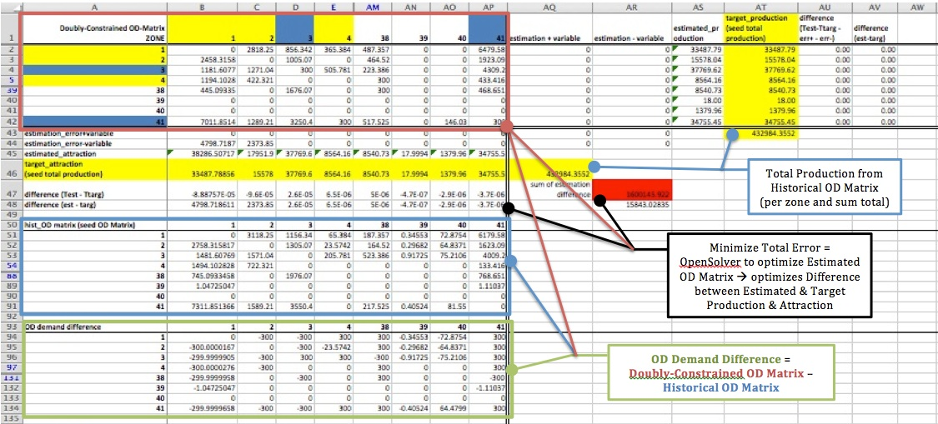

Figure 3.1: Complete OD estimation model. Note that in the interest of space and clarity, rows and columns 5-37 have been hidden in each matrix.

In Excel, the OD-demand matrix established in Module 2 (singly-constrained model) is used as the ‘seed’ matrix. It represents the historical OD-demand for the network (Figure 3.2).

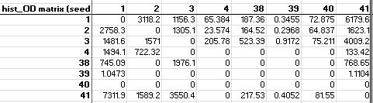

Figure 3.2: Historic OD-demand Matrix (‘seed’ matrix). Note that in the interest of space and clarity, rows and columns 5-37 have been hidden.

The total production from the ‘seed’ matrix is then the target production *and* attraction for the doubly constrained OD-demand matrix (Figure 3.3).

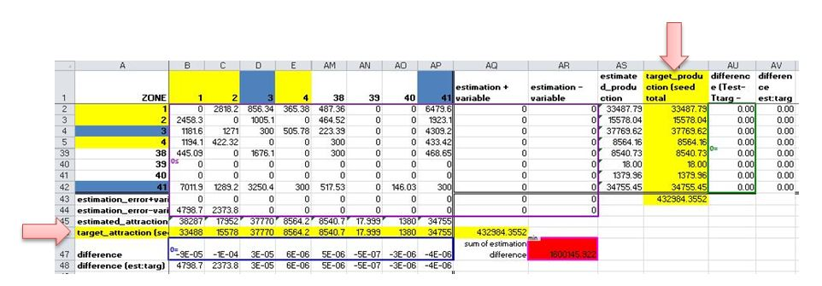

Figure 3.3: Target attraction & production are equal to the sum total of the historic target production for each zone. Note that in the interest of space and clarity, rows and columns 5-37 have been hidden.

Since the built-in ExcelSolver alone is not powerful enough to handle the 41 x 41 matrix for this problem, OpenSolver ([opensolver.org/](http://opensolver.org/)) as an open-source add-in to Excel to find an optimized solution for larger, more complicated optimization models (Figure 3.4).

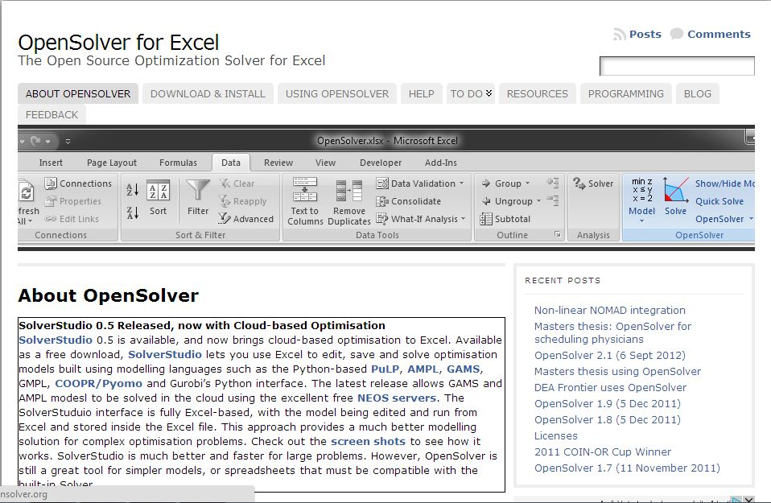

Figure 3.4: OpenSolver for Excel is used to solve complex optimization models that the standard Excel Solver cannot handle.

*Step 2: Add constraints to the model.*

Constraints may include through-trip percentage, observed AADT and capacity constraints for each zone. Use the seed OD-demand table (from Module 2) as a reference.

Using the OpenSolver, we can calibrate our model with the OD-demand difference matrix. Model constraints can be programmed into the OpenSolver to limit the acceptable level of error in the model between the singly-constrained historical OD-demand matrix and the new, doubly constrained matrix (Figure 3.5). For this network, we limited the model to a difference of 300 trips, but a trial-and-error process can be used to identify the demand difference that will minimize the total error in the model.

When the OpenSolver is run, the resulting estimated OD-demand matrix, should be balanced with minimal error.

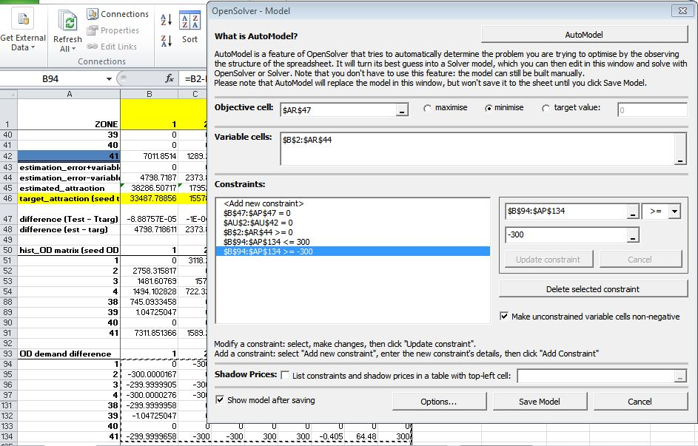

Figure 3.5: Open Solver input window.

*Step 3: Solve the optimization problem and provide an updated OD-demand table, with minimized error.*

References:

Ch. 5.2 -- 5.3, Modeling Transport, 4th Edition, by Juan de Dios Ortúzar and Luis G. Willumsen

<http://www.easts.info/on-line/journal_06/1708.pdf>

<http://classes.uleth.ca/200803/geog3235a/Constrained_gravity_model_2008.pdf>

<http://ocw.tudelft.nl/fileadmin/ocw/opener/slides_lecture_3.pdf>

**Module 4: OD demand estimation using link counts**

Author: Anusha Musunuru

Input: updated OD demand table, link capacity constraints

output: final estimated OD demand table from link counts

Reference: [https://docs.google.com/document/d/1lZXpv4szSXDz0-TII4yaL3OwqUtdsK2FM0nLLJCTaDg/edit#heading=hs.gjdgx](https://docs.google.com/document/d/1lZXpv4szSXDz0-TII4yaL3OwqUtdsK2FM0nLLJCTaDg/edit#heading=h.gjdgxs)

*Introduction:*

Accurate origin-destination (OD) trip volume estimates are required by the many traffic planning applications to evaluate network flow conditions that result from the travel decisions of individual travelers/agents. In this project, an initial OD matrix is generated using the gravity model and the external-external trip rates and another OD matrix is obtained against the peak hour volume.

*Data Collection:*

The Annual Average Daily Traffic (AADT) data was collected for the West Jordan Network from the Wasatch Front Regional council (WFRC) and Utah Department of Transportation (UDOT) maps. It is assumed that the peak hour volume is equal to (0.1*AADT). The data were imported to NEXTA and are stored in input_sensor data file.

Step 1: prepare link counts on peak hours

The peak hour counts are inserted in NEXTA. All the counts are assigned to the respective links in NEXTA. Remember that the total count will be shared by the links in both directions. The table below shows the AADT counts for the respective links in NEXTA.

|  |  |  |  |
| --- | --- | --- | --- |
| **Link ID** | **from_node_id** | **to_node_id** | **Total count** |
| 5216 | 5216 | 5356 | 22678 |
| 5356 | 5356 | 5216 | 22678 |
| 5214 | 5214 | 11261 | 16855 |
| 11261 | 11261 | 5214 | 16855 |
| 5208 | 5208 | 5209 | 12730 |
| 5209 | 5209 | 5208 | 12730 |
| 5112 | 5112 | 11172 | 13342 |
| 11172 | 11172 | 5112 | 13342 |
| 11160 | 11160 | 5113 | 13062 |
| 5113 | 5113 | 11160 | 13062 |
| 5017 | 5017 | 5018 | 18570 |
| 5018 | 5018 | 5017 | 18570 |
| 5022 | 5022 | 4952 | 4525 |
| 4952 | 4952 | 5022 | 4525 |
| 5436 | 5436 | 11125 | 15400 |
| 11125 | 11125 | 5436 | 15400 |
| 5436 | 5436 | 5578 | 19522 |
| 5578 | 5578 | 5436 | 19522 |
| 5112 | 5112 | 5589 | 21792 |
| 5589 | 5589 | 5112 | 21792 |

Step 2: obtain link flow proportions from NEXTA

The observed counts are the link flow proportions obtained from NEXTA. The estimated flow counts are the ones which are obtained by multiplying the OD volume by the percent of traffic from node i to node j using link l.

for a given l

A graph is plotted between the observed and the estimated counts. It looks as follows:

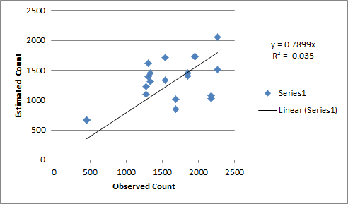

Then the deviation of observed and estimated counts is calculated by using the least squares method. The deviation is given by for all the links l. Our goal is to minimise the total error as much as possible.

Step 3: perform OD demand estimation using link counts, (or converted production and attraction) with link capacity constraints, (through trip percentage)

The historical OD table is the one generated using the gravity model. The OD matrix generated by using the gravity model is 41X41 , the excel solver cannot be used to solve such huge matrix. So we select 300 pairs in the matrix which were thought to affect the result significantly.

The method used to minimise the error is the least squares method. When solving the model using the excel solver,

Objective Function :

Step 5: calibration results: simulated vs. observed data counts

After solving the model, we get a good relation between the observed and estimated link counts. It is shown in the graph below:

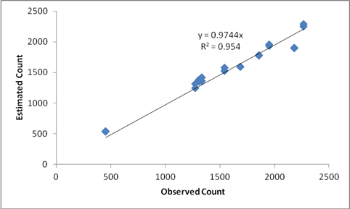

|  |  |  |  |
| --- | --- | --- | --- |
|  |  |  |  |

A graph is drawn between original OD table and the final “optimised” OD table. It is seen that there are only some changes which are insignificant. The graph is shown below:

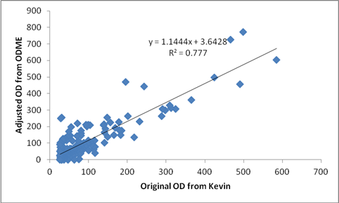

We got the value of R-square to be 0.777, which seems to be good. Hence we can notice that the original OD numbers obtained from gravity model are in accordance with the adjusted OD from ODME using the peak hour link counts from NEXTA.

The link for the excel sheet is (Link should be provided)